**OrthoAnalyzer**

**PATIENT**

**CASE**

**• ID:** 2112035040

**• SSN:**

**• Name:** HARDEEP SINGH

**• Address:**

**• City:**

**• Country:** INDIA

**• Clinic ID:** CLOVE DENTAL

**• ID:** 2112035040

**• Operator:** DR. VIKRANT BHANDARI

**• Comment:**

**• Date:** 30‑Dec‑21

**• Scan date:** 30‑Dec‑21 12:33:35 PM

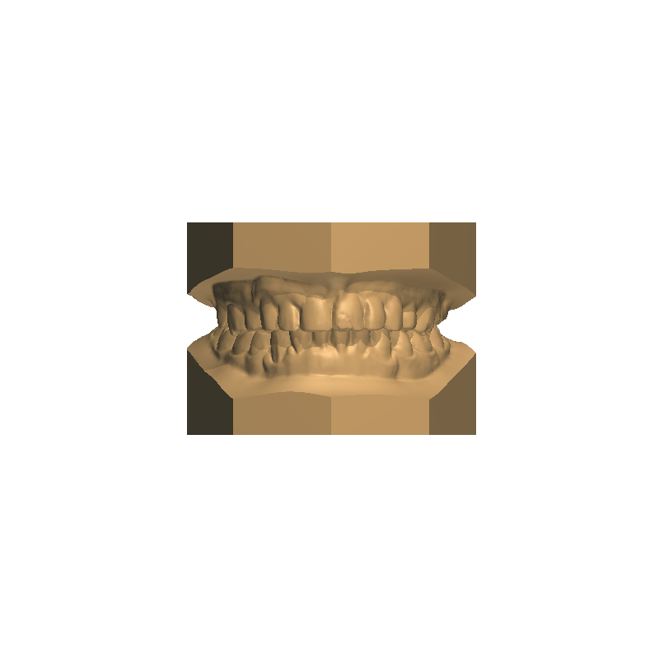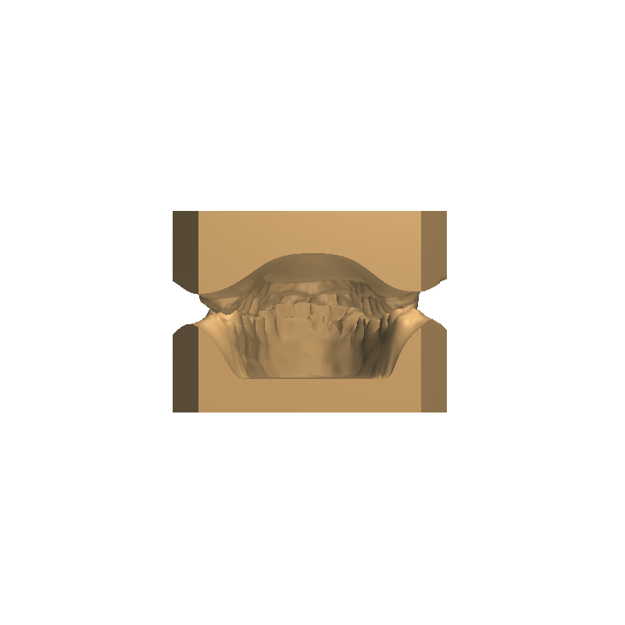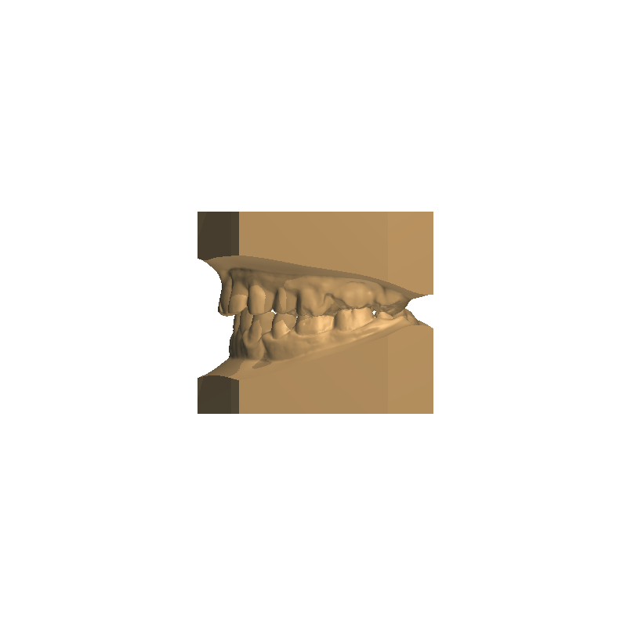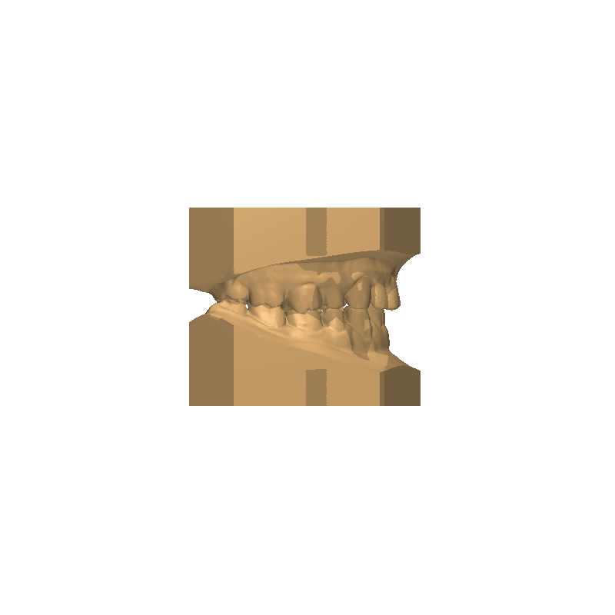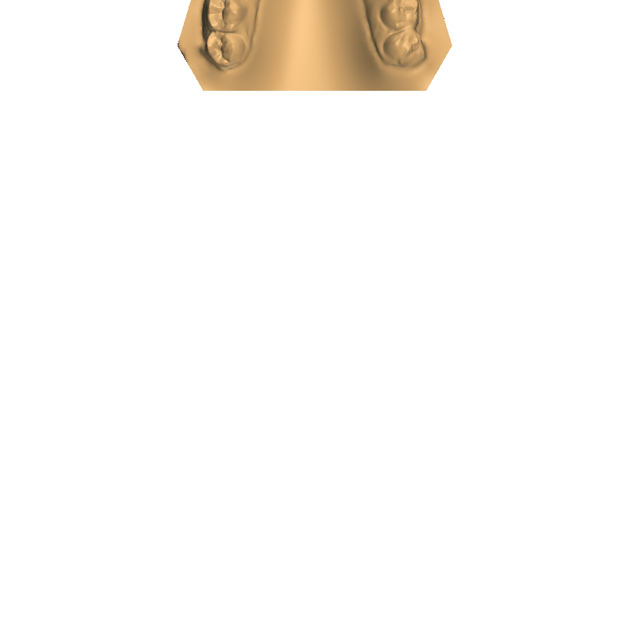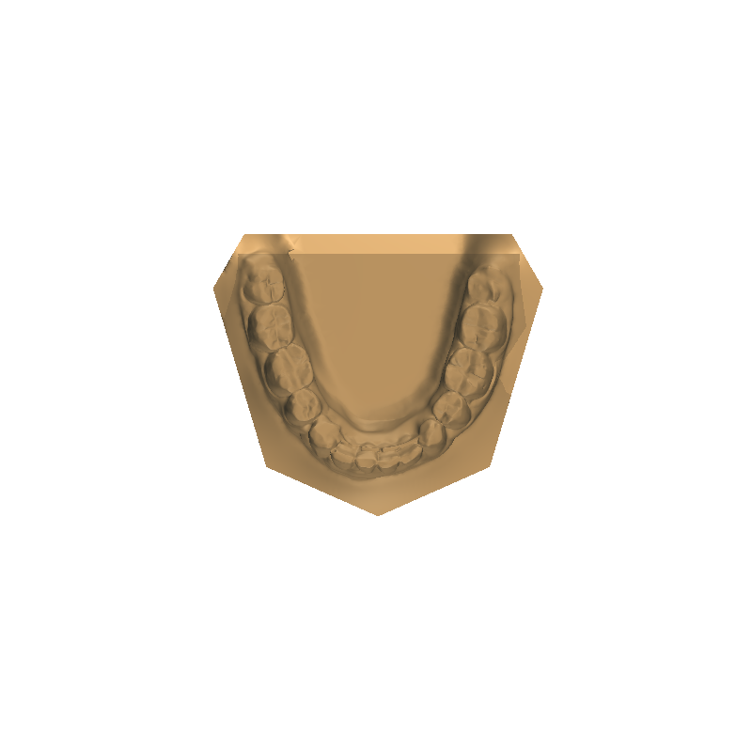Page 1 of 11



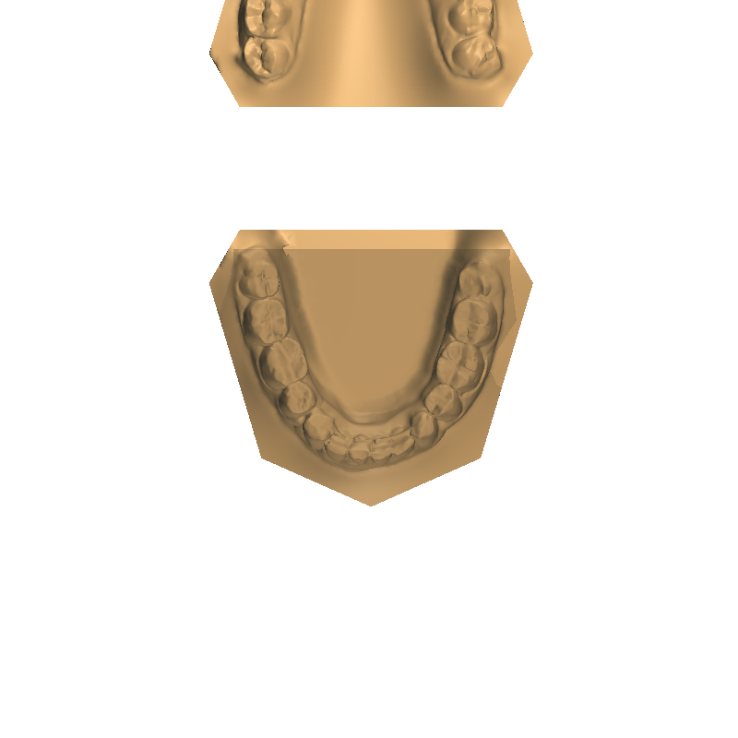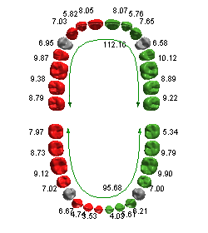**Overview**

**Ideal curve**

0.00

**Ideal length**

0.00

**Bracket offset_length**

**•**

**•**

**Ideal arch analysis**

**OVERALL BOLTON ANALYSIS**

*Ideal ratios*

*Maxillary 6 width:*

*Mandibular 6 width:*

*Ratio:*

**•**

**•**

**•**

**•**

Page 2 of 11



**Default**

Table:

**Tooth width analysis**

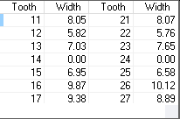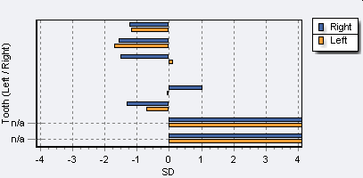**MAXILLARY TOOTH WIDTH ANALYSIS**

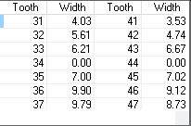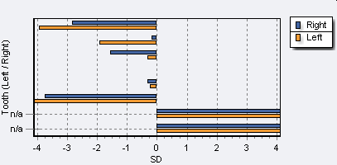**MANDIBULAR TOOTH WIDTH ANALYSIS**

**OVERALL BOLTON ANALYSIS**

*Ideal ratios*

*Maxillary 6 width:*

*Mandibular 6 width:*

*Ratio:*

**•**

**•**

**•**

**•**

Page 3 of 11



**ANTERIOR BOLTON ANALYSIS**

*Maxillary 6 width:*

*Mandibular 6 width:*

*Ratio:*

0.73

30.80

42.37

*Ideal ratios*

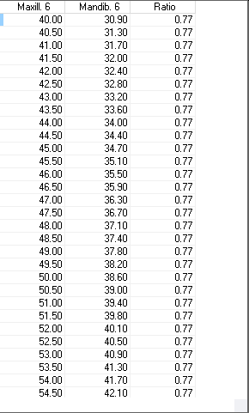**•**

**•**

**•**

**•**

**Bolton analysis**

**OVERALL BOLTON ANALYSIS**

75.88

63.85

0.84

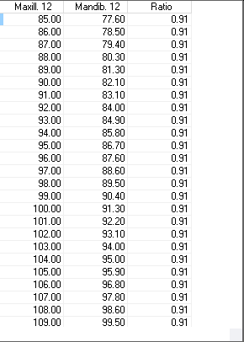*Ideal ratios*

*Maxillary 6 width:*

*Mandibular 6 width:*

*Ratio:*

**•**

**•**

**•**

**•**

Page 4 of 11



**OVERALL BOLTON ANALYSIS**

*Ideal ratios*

*Maxillary 6 width:*

*Mandibular 6 width:*

*Ratio:*

**•**

**•**

**•**

**•**

**Default**

Table:

**Space analysis**

**MAXILLARY SPACE ANALYSIS**

*Total space available:*

27.70

55.90

*Sum of left canine & premolars:*

1.#J

*Sum of right canine & premolars*

*Total space required*

*Discrepancy*

**Moyers**

**Tanaka & Johnston**

1.#J

1.#J

1.#J

19.96

19.96

67.61

‑11.71

**•**

**•**

**•**

**•**

**•**

**•**

*Sum of left canine & premolars:*

*Sum of right canine & premolars*

*Total space required*

*Discrepancy*

**•**

**•**

**•**

**•**

*Sum of incisor widths*

**MANDIBULAR SPACE ANALYSIS**

17.91

44.82

1.#J

1.#J

1.#J

1.#J

19.46

19.46

56.83

‑12.01

*Total space available:*

*Sum of incisor widths*

**•**

**•**

*Sum of left canine & premolars:*

*Sum of right canine & premolars*

*Total space required*

*Discrepancy*

**Moyers**

**•**

**•**

**•**

**•**

**Tanaka & Johnston**

*Sum of left canine & premolars:*

*Sum of right canine & premolars*

*Total space required*

*Discrepancy*

**•**

**•**

**•**

**•**

**Screen snaphots**

**• Date:** 11‑Feb‑22 5:32:26 PM

**• Comment:**

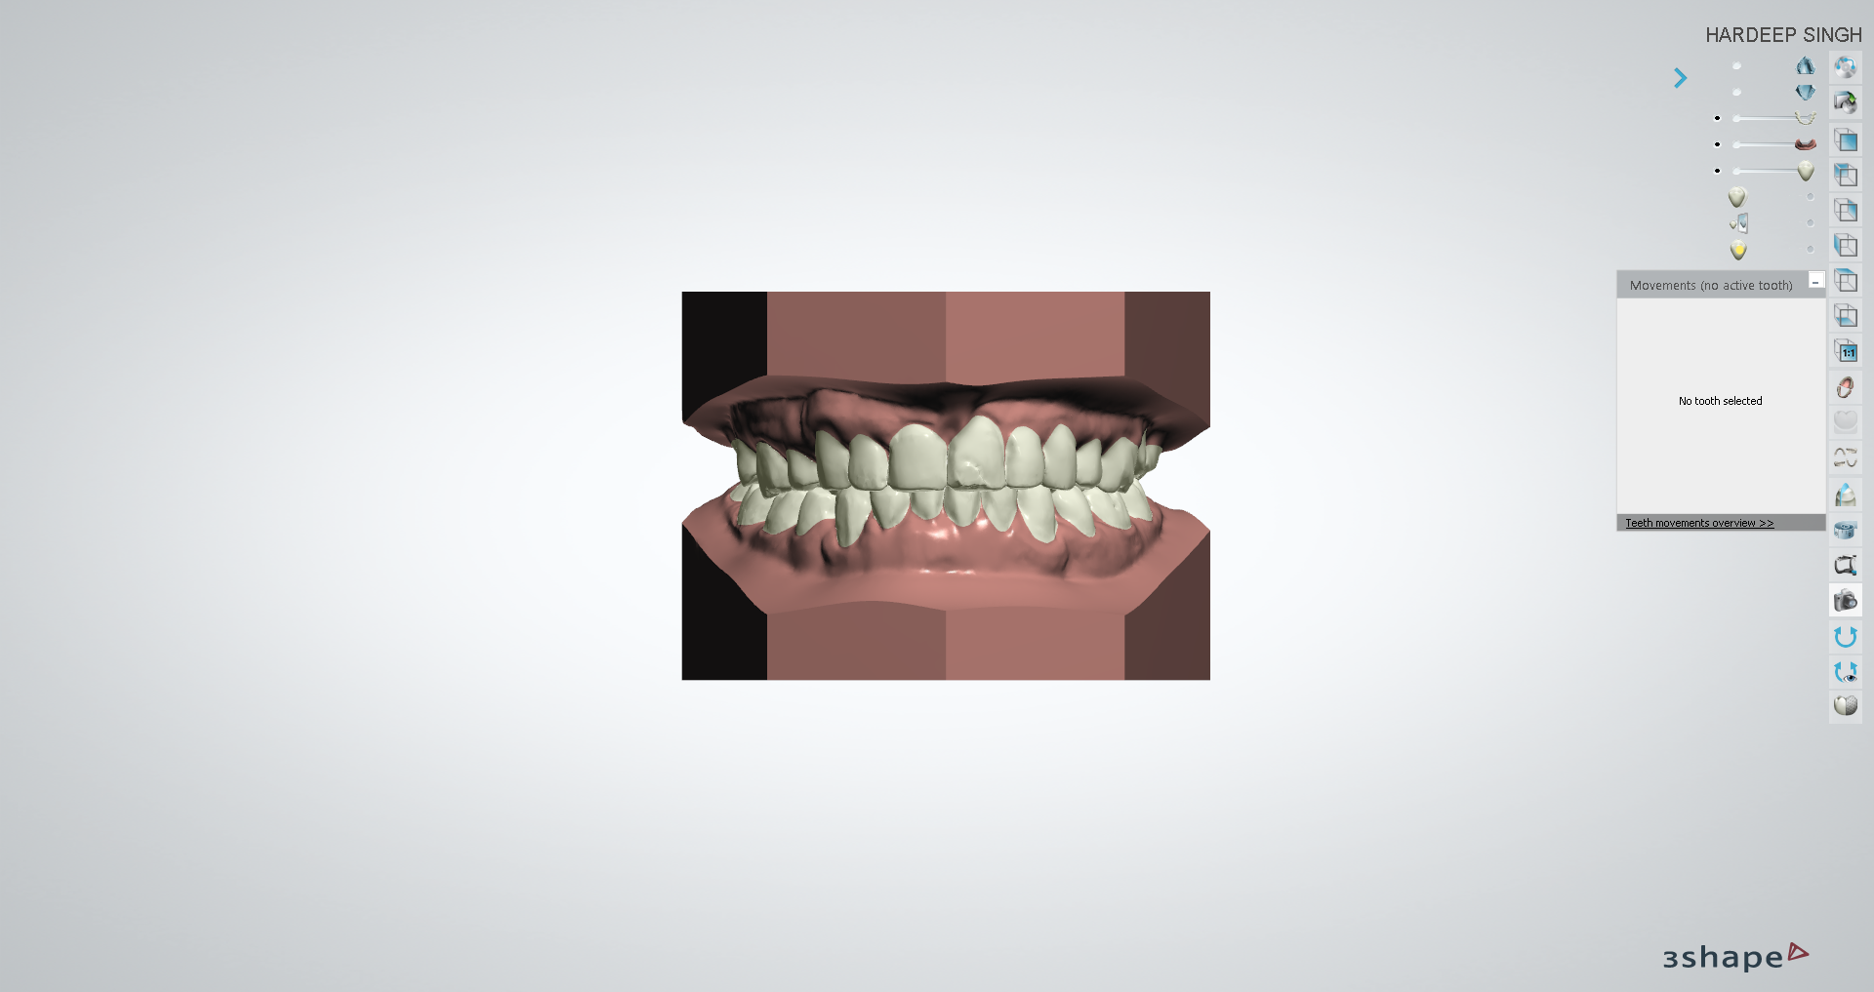**• Date:** 11‑Feb‑22 5:32:33 PM

**• Comment:**

Page 5 of 11



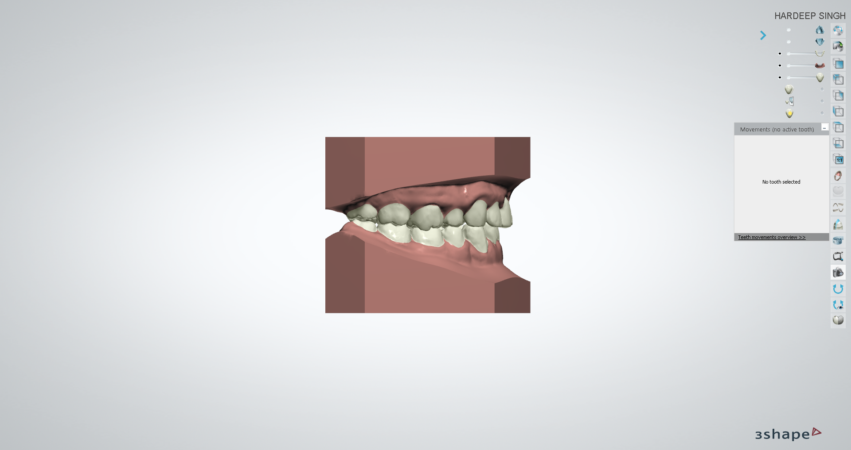**• Date:** 11‑Feb‑22 5:32:39 PM

**• Comment:**

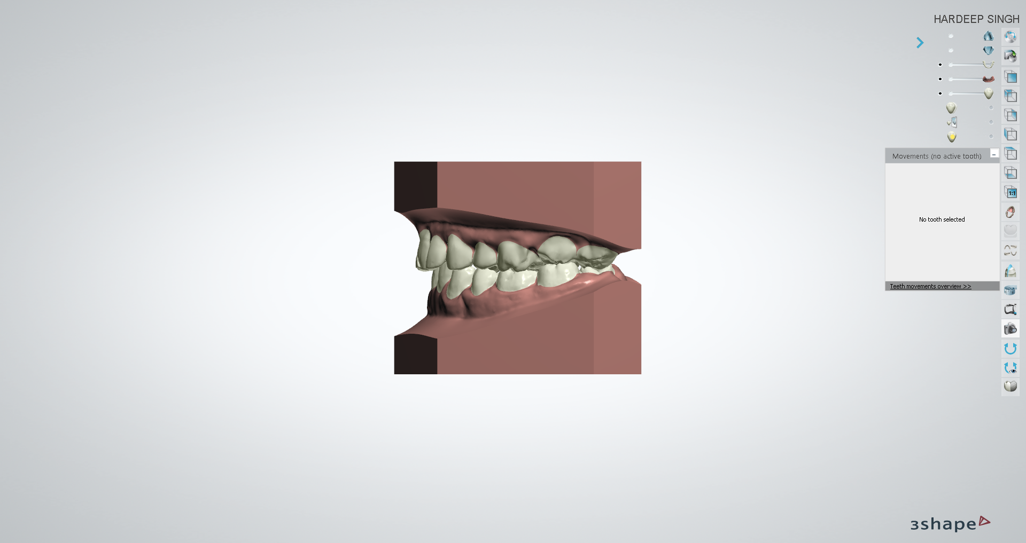**• Date:** 11‑Feb‑22 5:32:47 PM

**• Comment:**

Page 6 of 11



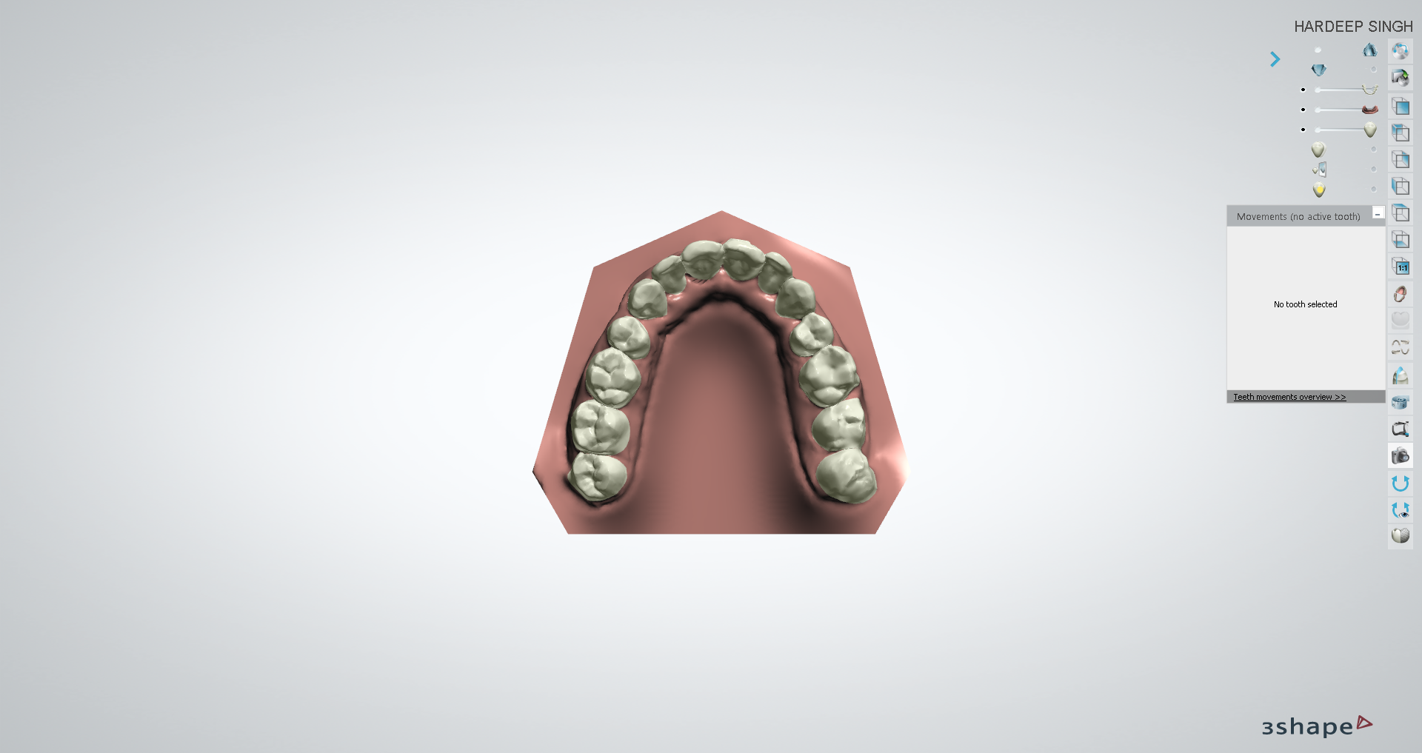**• Date:** 11‑Feb‑22 5:32:56 PM

**• Comment:**

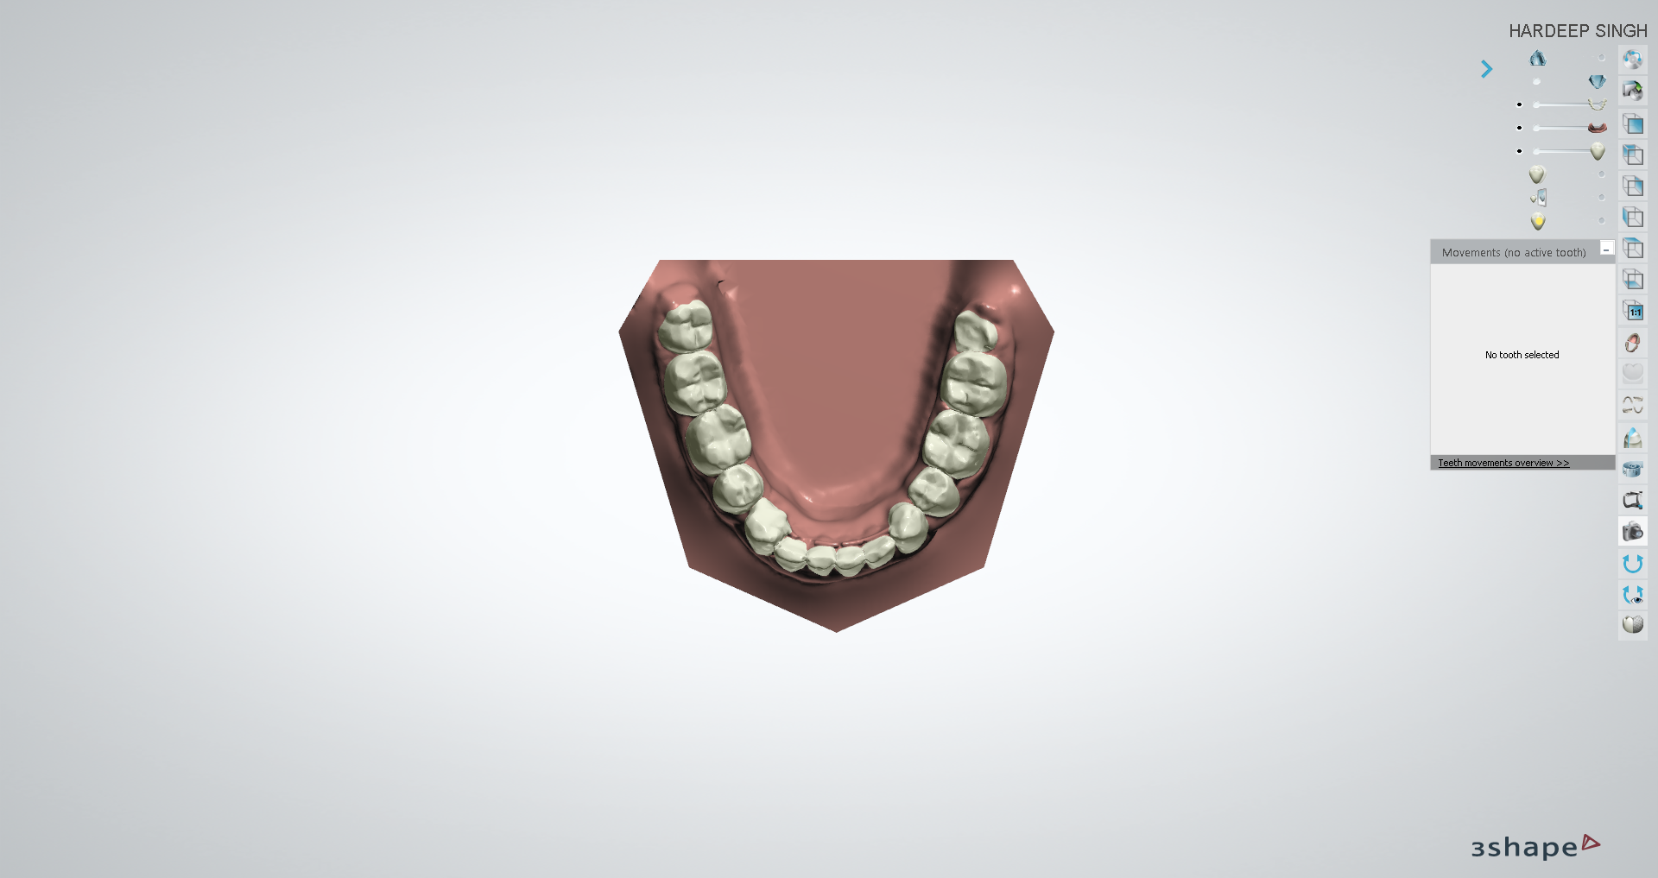**• Date:** 11‑Feb‑22 5:33:12 PM

**• Comment:**

Page 7 of 11



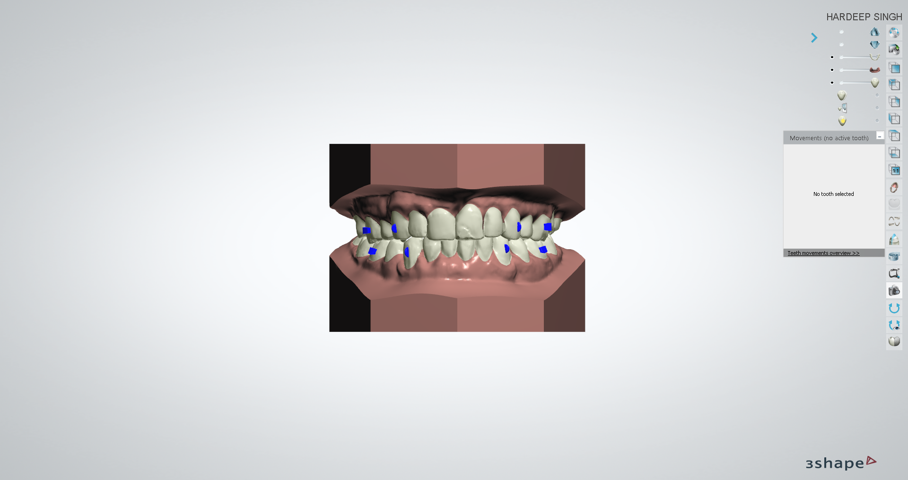**• Date:** 11‑Feb‑22 5:33:27 PM

**• Comment:**

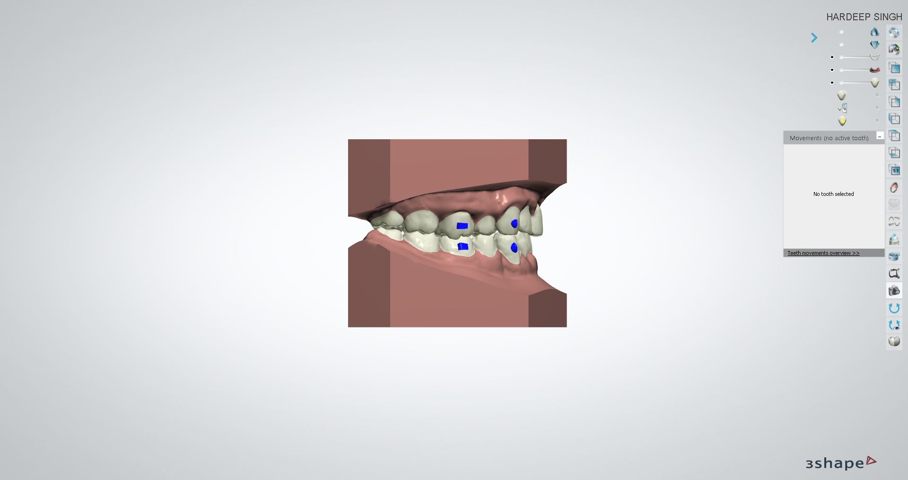**• Date:** 11‑Feb‑22 5:33:39 PM

**• Comment:**

Page 8 of 11



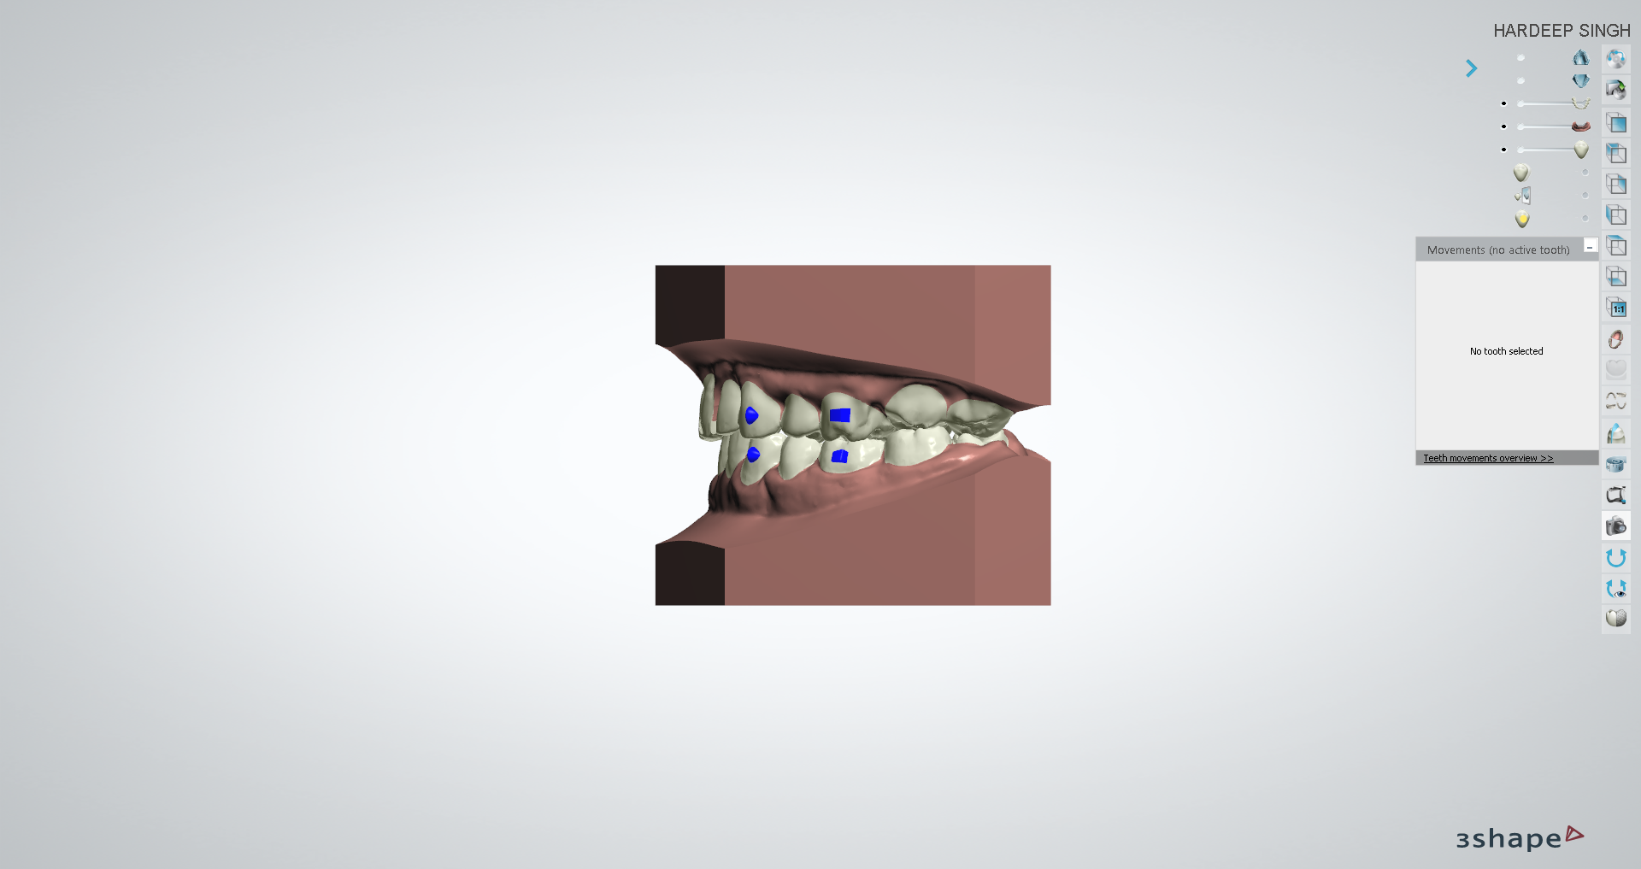**• Date:** 11‑Feb‑22 5:33:53 PM

**• Comment:**

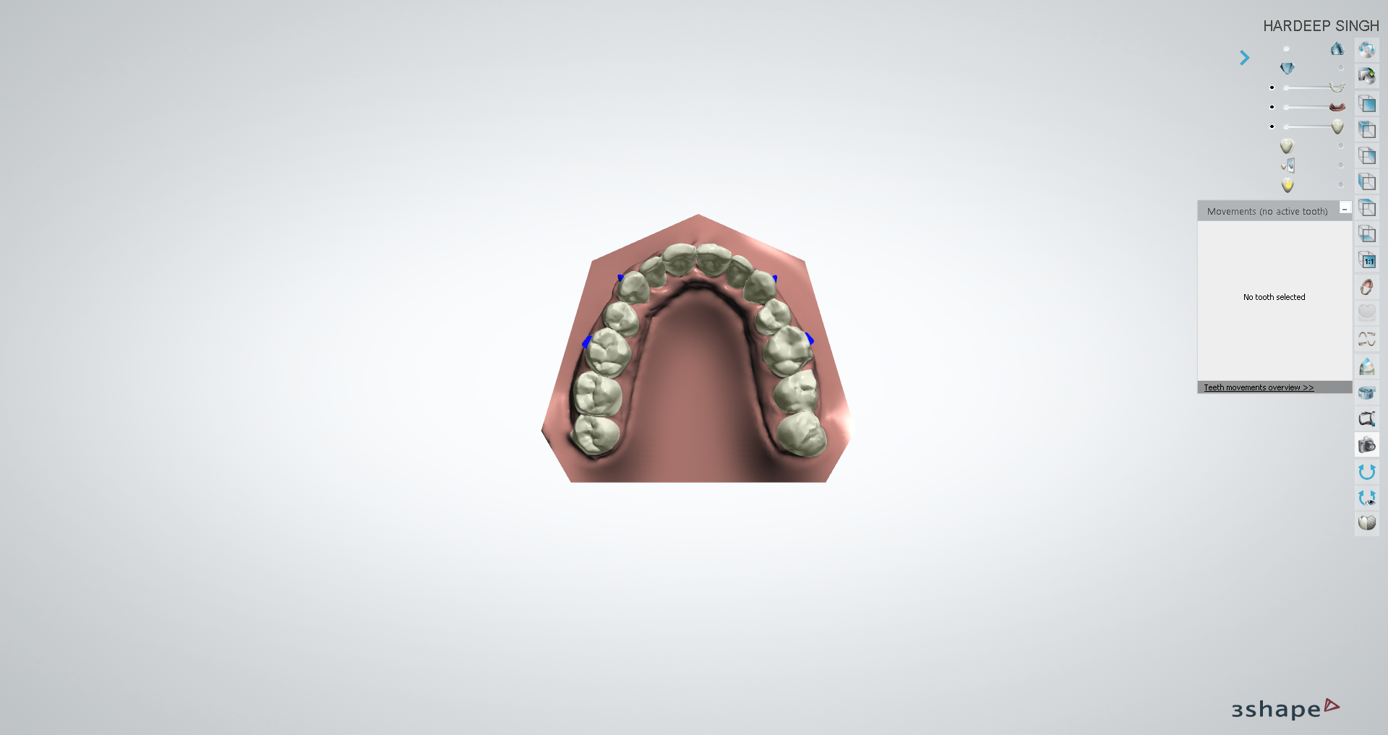**• Date:** 11‑Feb‑22 5:34:09 PM

**• Comment:**

Page 9 of 11



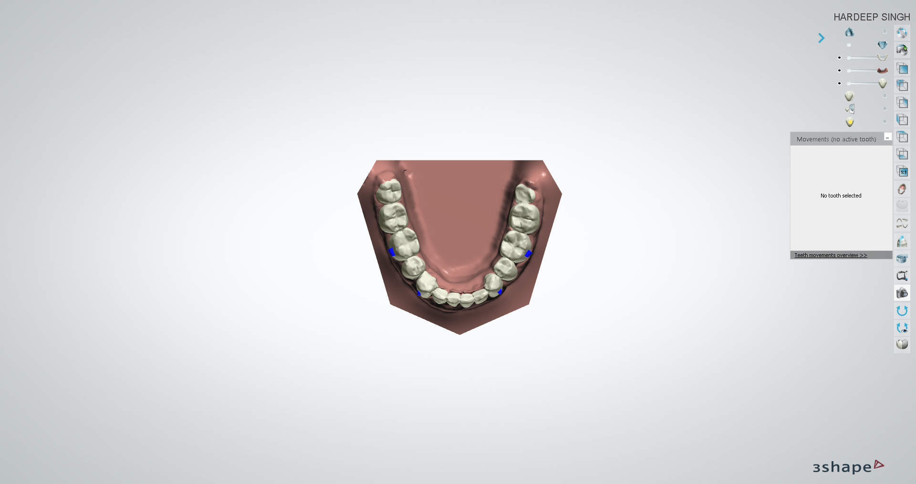**Schwartz Korkhaus Analyses** (Unweighted Total: **0.00,** Weighted Total: **0.00**)

UW: 0.00 W: x1.00 = 0.00

**Korkhaus Schwartz Maxilla**

Korkhaus A

27.70

**•**

Korkhaus B (Line Korkhaus U4_4)

value is undefined

**•**

Korkhaus B Ideal

34.50

**•**

Korkhaus B Discrepancy

value is undefined

**•**

Korkhaus C (Line Korkhaus U6_6)

value is undefined

**•**

Korkhaus C Ideal

44.30

**•**

Korkhaus C Discrepancy

value is undefined

**•**

Korkhaus D (Korkhaus Distance U1_1)

value is undefined

**•**

Korkhaus D Ideal

18.30

**•**

Korkhaus D Discrepancy

value is undefined

**•**

UW: 0.00 W: x1.00 = 0.00

**Korkhaus Schwartz Mandible**

Korkhaus B1 (Korkhaus Line L4_4)

value is undefined

**•**

Korkhaus B1 Ideal

34.50

**•**

Korkhaus B1 Discrepancy

value is undefined

**•**

Korkhaus C1 (Korkhaus Line L6_6)

value is undefined

**•**

Korkhaus C1 Ideal

43.30

**•**

Korkhaus C1 Discrepancy

value is undefined

**•**

Page 10 of 11



**Teeth Movement Report**

**Setup:**

Tooth Number

Rotation

Angulation

Incli‑ nation

Left/

Right

Extrusion/ Intrusion

Forward/ Backward

Long Axis

Circum‑ference

**05‑01‑2022 12:40:15**

IPR Distal (mm)

IPR Mesial (mm)

13

‑2.6 deg

‑0.6 mm

0.6 mm

81.0 deg

25.4 mm

12

‑2.0 deg

‑1.1 mm

1.0 mm

‑0.2 mm

78.0 deg

20.6 mm

11

‑2.0 deg

‑0.9 mm

0.2 mm

‑0.4 mm

77.3 deg

26.2 mm

21

‑12.8 deg

‑2.0 deg

0.5 mm

0.3 mm

‑0.7 mm

78.0 deg

26.2 mm

22

‑4.0 deg

‑0.2 mm

1.0 mm

‑0.4 mm

75.1 deg

21.8 mm

33

‑0.2 mm

‑0.1 mm

87.7 deg

24.2 mm

32

‑4.2 deg

‑0.4 mm

0.5 mm

86.7 deg

18.2 mm

31

‑7.9 deg

‑0.3 mm

1.0 mm

‑0.4 mm

84.4 deg

17.0 mm

41

3.0 deg

0.2 mm

1.0 mm

‑0.7 mm

84.3 deg

17.1 mm

42

7.9 deg

0.1 mm

1.0 mm

‑1.1 mm

83.2 deg

19.1 mm

43

‑0.3 mm

0.4 mm

‑0.2 mm

78.0 deg

28.4 mm

**Setup:**

Tooth Number

Rotation

Angulation

Incli‑ nation

Left/

Right

Extrusion/ Intrusion

Forward/ Backward

Long Axis

Circum‑ference

**Upload Plan**

IPR Distal (mm)

IPR Mesial (mm)

13

‑2.6 deg

‑0.6 mm

0.6 mm

81.0 deg

25.4 mm

Manual

Manual

12

‑2.0 deg

‑1.1 mm

1.0 mm

‑0.2 mm

78.0 deg

20.6 mm

Manual

Manual

11

‑2.0 deg

‑0.9 mm

0.2 mm

‑0.4 mm

77.3 deg

26.2 mm

Manual

Manual

21

‑12.8 deg

‑2.0 deg

0.5 mm

0.3 mm

‑0.7 mm

78.0 deg

26.2 mm

Manual

Manual

22

‑4.0 deg

‑0.2 mm

1.0 mm

‑0.4 mm

75.1 deg

21.8 mm

Manual

Manual

23

79.2 deg

25.8 mm

Manual

Manual

33

‑0.2 mm

‑0.1 mm

87.7 deg

24.2 mm

32

‑4.2 deg

‑0.4 mm

0.5 mm

86.7 deg

18.2 mm

31

‑7.9 deg

‑0.3 mm

1.0 mm

‑0.4 mm

84.4 deg

17.0 mm

41

3.0 deg

0.2 mm

1.0 mm

‑0.7 mm

84.3 deg

17.1 mm

42

7.9 deg

0.1 mm

1.0 mm

‑1.1 mm

83.2 deg

19.1 mm

43

‑0.3 mm

0.4 mm

‑0.2 mm

78.0 deg

28.4 mm

Page 11 of 11

